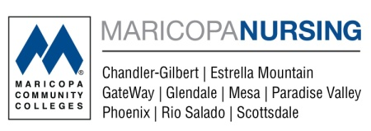

___________________________________________
Name

Fiction and Confidentiality Agreement for Simulation
The purpose of simulation-based training is for you to develop skills, including judgment and reasoning, for the care of real people. Using patient simulators and simulation teaching techniques, your instructors will recreate realistic patient care situations. The realism of each simulation may vary depending upon the learning goals for the session. The simulated environment and patient have certain limitations in their ability to exactly mirror real life.
When participating in the simulations, your role is to assume all aspects of a practicing healthcare provider’s professional behavior. Additionally, when a gap occurs between simulated reality and actual reality, it is expected that you try to understand the goals of the learning session and behave accordingly.
During your time in your program at Chandler-Gilbert Community College, you will participate in simulation, be observed by others and also observe the performance of others in managing clinical events.

To maintain the learning, safety, and integrity of the simulation environment, please maintain confidentiality regarding the performance of others and the details of the simulation scenarios. Sharing information about scenarios with students who have not yet participated is considered academic misconduct or cheating. ONLY approved electronic devices are to be used in this setting such as cell phones, iPods, laptops, or iPad/tablet(s) that have your learning resources to assist with the simulation. No tape recorders or video recording are permitted by students during this simulation.

Instructor Responsibilities:
- Create goal-oriented, practical simulations based upon measurable learning objectives.
- Add enough realism to each simulation so the learner receives sufficient clues to identify and solve a problem.
- Create and maintain a safe, productive learning environment.
- Maintain the integrity of simulation learning activities.
- Provoke interesting and engaging discussions, fostering reflective practice.
- Identify performance gaps and help close the gaps.

Learner Responsibilities:
- Suspend judgment of realism for simulation in exchange for the promise of learning new knowledge and skills.
- Maintain a genuine desire to learn even when suspension of disbelief becomes difficult.
- Treat the simulated patient with the same care and respect due an actual patient.
- Maintain confidentiality regarding the performance of others and the details of the simulation scenarios.

Video & Photo Release:
- The CGCC Nursing Program’s photography / video release document applies to simulation.

By signing below, I acknowledge that I have read and understood this contract. I will maintain
confidentiality about any observations, the performance of individuals, and the simulation
scenarios themselves.

______________________________ _______________________
Signature Date

